HISTORY OF THE CAMBRIDGE MECHANIC’S INSTITIUTE
The establishment and progress of the Cambridge Mechanic’s Institute is recorded in the local Cambridge press.

1835
Proposal to establish a Cambridge Mechanic’s Institute 12th March 1835
AT PUBLIC MEETING convened by the Worshipful the Mayor of Cambridge, in compliance with a numerous and respectably signed Requisition, to take into consideration the propriety of establishing a
MECHANIC'S INSTITUTE
in the Town of Cambridge, held at the Town Hall, on Thursday evening, the 12th day of March instant.
Mr. Alderman Stevenson, in the absence of the Mayor through indisposition, took the chair, for the purpose of reading the requisition; and having resigned it,
On the motion of the Rev. Professor Cumming, seconded by Ebenezer Foster, Esq the Rev. Professor Henslow was unanimously called to the Chair.

- On the motion of the Rev. Professor Cumming, seconded by H Headly. Esq, Resolved-" That in the opinion of this meeting, the establishment of Mechanic's Institutes has been highly beneficial, by more widely diffusing useful knowledge, and improving the character of the working classes."
- On the motion of George Fisher, Esq., seconded by W. G. Ashton, Esq
Resolved -" That it is expedient that a Mechanic's Institution be established in the Town of Cambridge, to be called “THE CAMBRIDGE AND CAMBRIDGESHIRE MECHANIC'S INSTITUTE," with such accommodation for Lectures, Library, Museum, and Philosophical Apparatus, as the funds will admit of “
- On the motion of the Rev. J. Bowstead, seconded by the Rev. J. J. Smith, Resolved-" That the objects of the Cambridge and Cambridgeshire Mechanic's Institute, shall be the cultivation of experimental, natural, and moral philosophy, and of useful and practical knowledge in every department, avoiding political and religious controversy."
- ﻿﻿﻿On the motion of Ebenezer Foster, Esq, seconded by the Rev. G. W. Craufurd, Resolved-" That the Right Honourable the Earl of Hardwicke be requested to become the Patron of the Institute."

Further resolutions were passed to establish the members of a provisional committee, appoint a treasurer and secretary and “that Donations and Subscription lists be opened (by permission) at the Banks, and some of the Booksellers' shops, and at the houses of the Treasurer and Secretaries”.
(Cambridge Chronicle and Journal - Friday 20 March 1835 Page 2)

The Institute seems was established very quickly as reported here
A general meeting of the members of the Cambridge and Cambridgeshire Mechanics Institute was held at the large room of the Red Lion inn, Thursday evening, the 11th inst.; the Rev. Professor Cumming, the president, in the chair. The rules of the Society, which give at length in our last page, were read over and confirmed, officers elected, &c We understand the President will on Tuesday evening next deliver an introductory lecture, at the above place.
(Cambridge Chronicle and Journal - Friday 19 June 1835)

The reported rules are the “RULES OF THE CAMBRIDGE AND CAMBRIDGESHIRE Mechanics’ Institute” and reports are indiscriminate with the apostrophe.

OBJECTS
- The objects of the Cambridge und Cambridgeshire Mechanics' Institute shall be the cultivation of experimental, natural, and moral philosophy, and of useful and practical knowledge in every department, avoiding political and religious controversy.
- These objects ire proposed to be effected by means of a library of reference and circulation, a reading-room. museum, and philosophical apparatus, occasional lectures on the various arts and sciences, and the formation of classes among the members.

The Introductory lecture given by the President Rev Prof Cummings was delivered “to a large and respectable audience”.
(Cambridge Chronicle and Journal - Friday 26 June 1835)

1836
Accommodation & appointment of a Librarian
A year later, June 1836, temporary accommodation had been secured
The Committee of the Mechanics Institute have obtained eligible house in central part of the town, which will opened in a few weeks; and it is hoped the superior accommodation thus afforded will induce an increase in the (already large) lists of both annual and quarterly members. We hear that it is in contemplation to give monthly lectures, arrangements for which are made up to October next.
(Cambridge Chronicle and Journal - Friday 17 June 1836)

Their first Annual report indicated the committee were endeavouring to acquire a permanent location.

At the end of June 1836 they placed an advertisement for a Librarian.

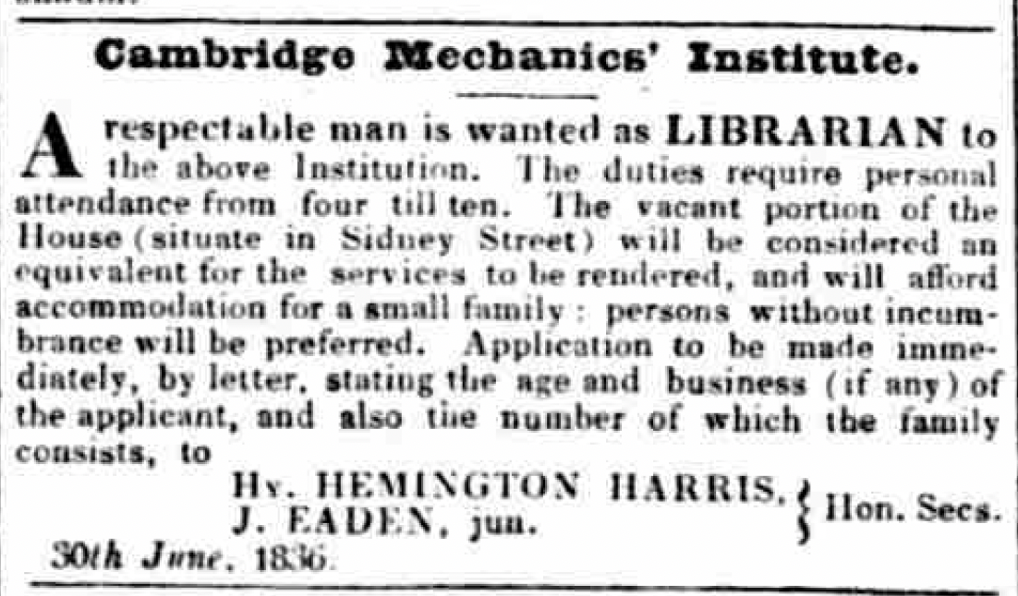

He (for of course it was for a man) was to be in attendance at their premises in Sidney Street from ten till four and in lieu of payment would be given accommodation there. In May 1838 in a Notice in the paper the Librarian is given as Mr Pate.
The exact location in Sidney Street of the premises of the Mechanics’ Institute has not been traced.

In October 1836 an advertisement was placed to fill accommodation the Institute had had at the Wrestlers Inn (Petty Cury)
TO BE LET The LARGE ROOM at The Wrestlers Inn. recently occupied the Mechanics’ Institute. is capable of being divided so as to form excellent Offices. For particulars enquire of Mr. Patman, Wrestlers Inn, Cambridge.

1838
Early lectures to the Institute members
Cambridge Mechanics' Institute. —On Wednesday evening last Mr. Deck delivered lecture at the Town Hall, before the members of the Mechanics’ Institution, upon the origin, manufacture, and peculiar properties of glass
(Cambridge Chronicle and Journal - Saturday 11 August 1838)

We understand that Mr. Pryor, jun. intends to give an elementary lecture, on the first principle Mechanics, to his fellow members the Mechanics institute, in this town, Monday evening next, at the large room the Sun hotel
(Cambridge Chronicle and Journal - Saturday 10 November 1838)

On Monday evening the members the Mechanics’ Institute of this town were gratified with a lecture from Professor Gumming Magnetism as connected with Electricity.
(Cambridge Chronicle and Journal - Saturday 15 December 1838)

1845
Proposal to add a news room
Mechanics’ Institute.—At the recent annual meeting of the members of the Institute, a proposal was submitted for adding news room to the establishment, which was conditionally agreed to, and if carried into effect, will, for the annual contribution of one guinea, entitle the subscribers the advantages of a news room, as well as the use of the library (containing about 2000 volumes) and reading room of the institute. This arrangement is not intended to interfere with those persons who may desire to be members of the Mechanics' Institute only, which they will have the power of doing as at present.
(Cambridge Independent Press - Saturday 12 July 1845)

Closure of the Mechanics Institute Library
How long the Mechanics Institute continued in Cambridge is (as yet) unknown. In 1855 the Free Library had been established in Cambridge in Jesus Lane.
https://capturingcambridge.org/centre/park-street/friends-meeting-house/

In a report on ‘The Free Library and its finances’ in 1871 (Cambridge Independent Press - Saturday 07 January 1871) it is reported that the Mechanics’ Institute had contributed 1,200 volumes to the Library and it must be assumed that at this time the Institute no longer had its library.
The number of persons visiting the reading-room was ascertained from a census taken first, in December, 1860, and in one week it was 1,050, in 1863 that the number had increased 3,171 ; and lastly in August the present year, it was 14,592. The week in which the last census was taken was an exceptional one, in consequence of very exciting war news, but I think the average attendance at the present time may be safely estimated at from eight to ten thousand persons weekly. The number of persons borrowing books in 1863 was 1,156, and at the present time it is about 1,900. By a return recently made to Parliament from all the Free Libraries, an extract from which appears in our last report, it is found that none have met with greater success than that at Cambridge, both in the acquisition of books and the annual issue. It is desirable, however, to bear mind that this success in the past in the acquisition of books was due to several liberal donors, and among others, to the late Mr. James Reynolds, who contributed about one-fifth of the entire library ; to Mr. H. T. Hall, contributor of 1,200 volumes; to the Mechanics’ Institute, 1,200 volumes ; and to the late Mr. Charles Finch Foster and Mr, George Ebenezer Foster, who each contributed £100.
From the Rules and Regulations of the Cambridge and Cambridgeshire Mechanics’ Institute 1849

CIRCULATING LIBRARY.
- That the Library be open for delivering out, and receiving books, daily, (except on Sundays, Christmas-day, Good Friday, and Fast and Thanksgiving days by proclamation) from five o'clock in the afternoon, until ten o'clock at night.
- That every Member shall (if required) produce his Admission Ticket, on taking out, or returning a book.
- That no Member shall have more than one volume at a time, except in case of the plates belonging to any subject being in a separate volume, or the Member's residence being two miles or upwards from Cambridge, when two volumes may be taken out, but both volumes must be returned at the expiration of the time allowed for one.
- That two weeks be allowed for reading an octavo or smaller volume, three weeks for a quarto, and four weeks for a folio, including the days of delivery and return; and if the day of return happens on a day when the Institute is closed, the day after to be considered as the day of return.
- That if a book be not returned on the day appointed, the Member shall pay a fine of three pence for every day the book shall be detained; and if kept above seven days beyond the appointed time, sixpence a day; and if not returned within fourteen days after the day fixed for its return, application shall be made by the Secretaries to the Member for the same, and if not then returned, the Member shall pay the value thereof, or of the set of books to which it belongs, and in default of such payment he shall cease to be a Member of the Institute.
- That a Member lending a book to any person shall pay a fine of five shillings.
- That if a book be written in, or otherwise damaged or defaced, the Member in whose hands the book was at the time, shall pay the value of the book or replace the same, at the discretion of the Committee.
- That all fines be paid to the Librarian within one week after being incurred, and in default thereof, application shall be made for the same by the Secretaries at the discretion of the Committee, and if not paid within one week from such application, the persons so neglecting to pay such fines shall cease to be Members of the Institute.
- That no books, marked as books of reference, shall be circulated.
- That proper books be kept for entering books taken out of the Library, and for registering Members’ applications for books taken out.
- That if a book be not taken out by the Member first applying for it within three days after the day fixed for its return, the Member next in rotation shall be entitled to it.
- That a Member on returning a book may take the same again out of the Library, if no application for it has been previously made.
- That no new works (other than periodicals and duplicates) shall be circulated until after they have remained in the Library one month.
- That all periodical works (other than weekly, which shall continue a fortnight) shall remain on the Reading Room table until replaced by the succeeding numbers, when they may circulate.
- That to enable the Committee to ascertain the state of the Library, and the condition of the books therein, the circulation of books shall cease for one week twice in the year, such weeks to commence on the last Wednesday in May and November; that all books must be returned into the Library before the above days, and that any Member detaining a book after the specified days shall be fined One Shilling for each day it shall be so detained.

READING ROOM
- THAT the Room shall be open for the accommodation of the Members every day, (Sundays, Christmas-day, Good Friday, and Fast and Thanksgiving days excepted), from ten o'clock in the morning till ten at night.
- That no Member shall be entitled to enter the Reading Room without producing his card, if required.
- That Catalogues of the Books contained in the Library be placed in the Reading Room.
- That any Member taking the current number of a periodical work from the Room shall pay a fine of Five Shillings,
- That every Member requiring a Book for use in the Reading shall enter the title of the same with his signature, in a register to be kept for that purpose, and the Librarian, or person acting for him, shall countersign the entry when the book is returned into his possession.
- That no Member be allowed to write in any book belonging to the Library, or in any other manner deface or injure the same; and that every Member shall be responsible for whatever damage any volume shall sustain while in his possession, and for its loss, if not returned according to the fourth regulation,
- That for the general convenience of Members, it is earnestly requested that they will abstain from entering into any discourse. dispute, or discussion, as such conduct must necessarily interrupt and distract the attention of others.

Admission and Contribution of Members.
1. Persons making a Donation of not less than ten guineas, or two Donations of five guineas each, within three years, or presenting to the Institute books, philosophical instruments, or other property estimated at the value of twelve guineas by the Committee, or who shall have continued subscribing Members for twenty years, shall be deemed Life Members of the Institute.

2. Persons paying one guinea or upwards annually shall be termed Annual Members.

3. Persons paying two shillings and sixpence quarterly shall be termed Quarterly Members.

4. Candidates for admission shall be recommended by two Members of not less than six months' standing, in the following manner:
" We the undersigned. Members of the Cambridge and Cambridgeshire
" Mechanics' Institute, do hereby recommend A. B. of &c. as a fit and
"proper person to become a Member of the said Institute." *
This recommendation is to be delivered to the Librarian, who shall place it in a conspicuous part of the Reading-room, and if so placed a week before the next ensuing Committee Meeting, the person so proposed may (if approved by two-thirds of the Committee present) may be admitted a Member of the Institute at such next ensuing meeting; provided always that the Committee shall have the power of postponing the election of any one so proposed to the next Committee Meeting but one, after such notice is delivered to the Librarian: the person so elected shall, on application to the Secretaries, be admitted a Member, and on such admission and payment of his subscription must sign the Rules of the Institute, in a book kept for that purpose, and also the following declaration :
" I, A. B., do hereby promise to observe and keep all the Rules and
" Orders of the Cambridge and Cambridgeshire Mechanics' Institute."

5. In case of rejection by the Committee, the Candidate may, if he think fit, appeal to the next General Meeting.

6. The annual subscriptions (payable in advance) become due the 24th of June, and the quarterly subscriptions (payable in advance) the 24th of June, the 29th of September, the 25th of December, and the 25th of March, in every year. Any person becoming an
Annual Member, on or after the 25th of December, in any year, shall be required to pay ten shillings and sixpence only, as his subscription.

